**GOVERNMENT ARTS COLLEGE (A) SALEM-7**

**INDIAN AGRICULTURE CROP PRODUCTION**

**DEPARTMENT OF STATISTICS**

**S. KANNAN (TEAM LEADER) 21UST232509**

**(3EFDICAC9F76C 97BB064AAAE69D0735F)**

**TEAM MEMBERS ;**

**A.THIRUMURUGAN 21UST232520**

**( 546A62D57210401ACE04477FCCCA891D)**

**S. GOVINDARAJ 21UST232507**

## (AD36678C682454EAODE4E5478198455D)

**V. VIGNESH 21UST2325221**

## (D7BFD5F9DD5E70CB3F1441835AD86904)

***1******INTRODUCTION***

**1.1 Overview**

* This report delves into the captivating realm of India's agricultural cultivation, providing a comprehensive visual exploration of key aspects and trends in the agricultural sector. Through the visual representations, readers can gain valuable insights into crop production, seasonal variations, regional distribution, and overall production trends. These visualizations enable intuitive analysis, allowing stakeholders to uncover patterns, identify areas of growth or concern, and make data-driven decisions.
* By harnessing the power of Tableau, this report not only presents the data in a visually appealing manner but also provides an interactive experience for readers to explore the intricacies of India's agricultural cultivation. To Extract the Insights from the data and put the data in the form of visualizations, Dashboards and Story we employed.
  1. **PURPOSE:**
     + Indian agriculture plays a crucial role in the country's economy and food security. Crop production in India serves

several purposes, including:

* Food Security: The primary purpose of crop production in India is to ensure food security for its vast population. Crops such as rice, wheat, maize, and various pulses are grown to provide a stable and adequate food supply.
* Livelihoods: Agriculture is a significant source of livelihood for a large portion of the Indian population. Farmers cultivate crops to support their families and generate income through the sale of agricultural produce.
* Export: India exports a variety of agricultural products, including rice, wheat, cotton, spices, and fruits. Crop production for export purposes helps the country earn foreign exchange and boost its economy.
* Industrial Use: Some crops are grown for industrial purposes, such as sugarcane for sugar production and cotton for textile manufacturing.
* Animal Feed: Crops like maize and fodder crops are grown to provide feed for livestock and dairy animals.
* Cash Crops: Many crops, like cashew nuts, coffee, tea, and spices, are cultivated as cash crops to generate revenue and employment opportunities.
* Diversification: Crop production also involves diversification, where farmers grow a variety of crops to reduce risks associated with crop failure due to weather, pests, or diseases.
* Rural Development: Agriculture contributes to the development of rural areas by creating employment opportunities, increasing income, and improving infrastructure.
* Environmental Conservation: Sustainable agricultural practices, including crop production, can help conserve natural resources, reduce soil erosion, and promote biodiversity.
* Research and Development: Crop production serves as a platform for research and development in agriculture, leading to the development of improved crop varieties, pest-resistant plants, and innovative farming techniques.

2**. PROBLEM DEFINITION &DESIGN THINKING**

**2.1 EMPATHY MAP**

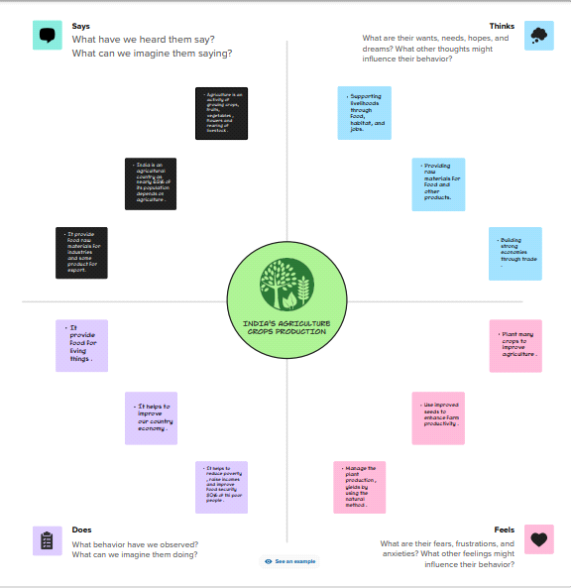

**2.2 IDEATION & BRAINSTORMING MAP**

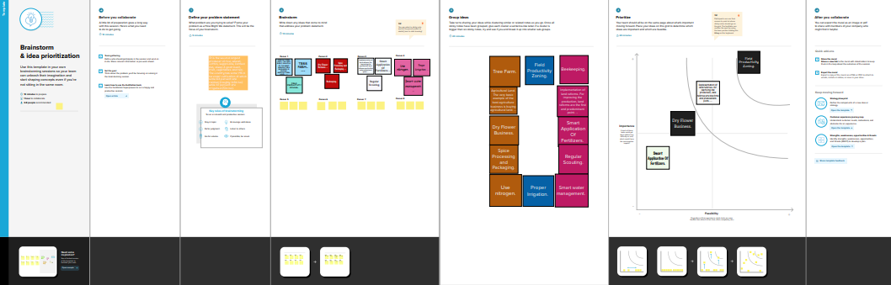

**3**. **RESULT**

* **Indian Agriculture Crop Production**
* **Sub-Branches:**
* **Major Crop Categories**
* **Cereals**
* **Pulses**
* **Oilseeds**
* **Fruits**
* **Vegetables**
* **Cash Crops (e.g., cotton, sugarcane)**
* **Crop Production Trends**
* **Yearly Production Data**
* **Historical Growth Rates**
* **Crop Rotation Patterns**
* **Regional Variations**
* **North India**
* **South India**
* **East India**
* **West India**
* **Central India**
* **Northeast India**
* **Key Crops and Their Production**
* **Wheat**
* **Rice**
* **Maize**
* **Pulses (e.g., lentils, chickpeas)**
* **Oilseeds (e.g., soybeans, mustard)**
* **Fruits (e.g., mangoes, bananas)**
* **Vegetables (e.g., potatoes, onions)**
* **Cash Crops (e.g., cotton, sugarcane)**
* **Challenges and Solutions**
* **Climate Change Impact**
* **Water Management**
* **Pest Control**
* **Technology Adoption (e.g., GMOs, precision farming)**
* **Government Initiatives (e.g., subsidies, crop insurance)**
* **Export and Import**
* **Major Exported Crops**
* **Import Trends**
* **Trade Partners**
* **Crop Yield and Productivity**
* **Average Yield per Hectare**
* **Efforts to Increase Productivity**
* **Crop Price Fluctuations**
* **Factors Affecting Prices**
* **Price Stabilization Measures**
* **Future Prospects**
* **Sustainable Agriculture Practices**
* **Diversification of Crops**
* **Technology Innovations**
* **Agricultural Policies**
* **Government Schemes (e.g., PM-KISAN)**
* **Subsidies and Support**
* **Farm Bills and Reforms**
* **Impact on Livelihoods**
* **Farmers' Income**
* **Employment Generation**
* **Rural Economy.**

**DASHBOARD**

**1.**

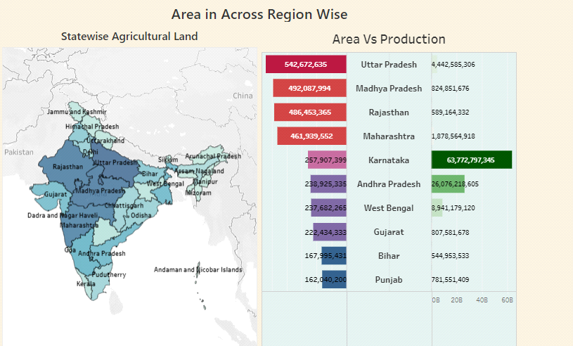

**2.**

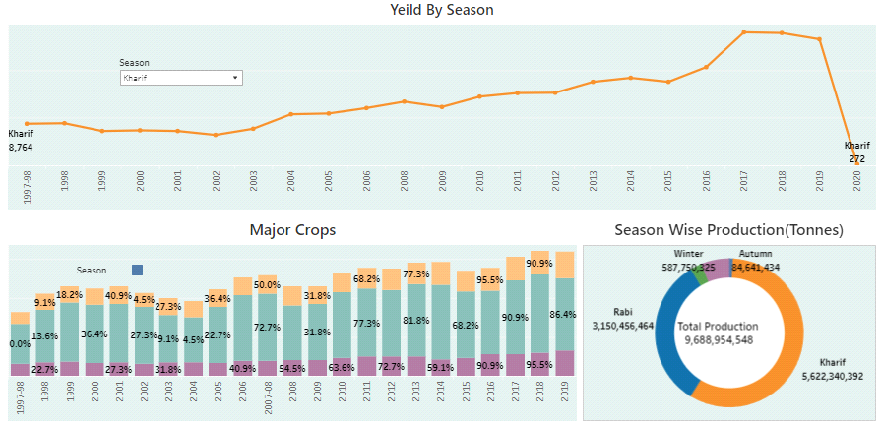

**3.**

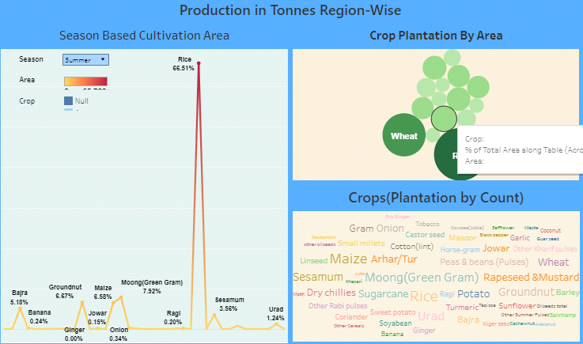

**STORY**

**1.**

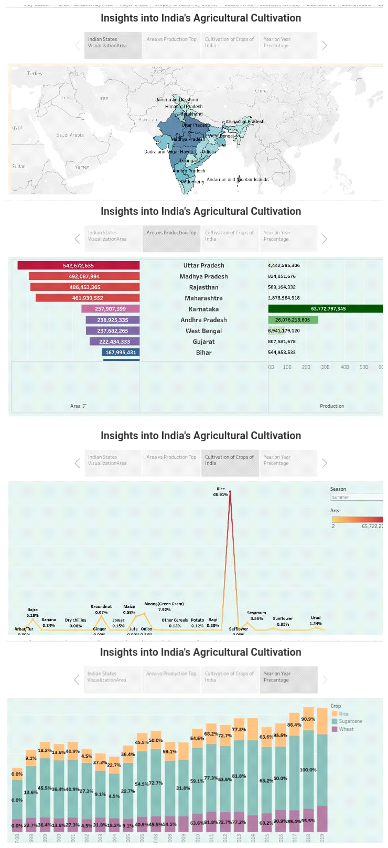

**2.**

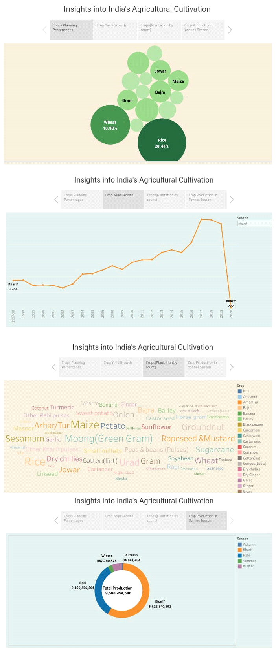

**4. ADVANTAGES & DISADVANTAGES**

**4.1 Advantages of Indian Agriculture Crop Production:**

* **Diverse Crop Portfolio: India's varied climate and geography allow for the cultivation of a wide range of crops, including rice, wheat, maize, sugarcane, cotton, pulses, oilseeds, and more. This diversity helps in ensuring food security and income generation.**
* **Employment Generation: Agriculture is a labor-intensive sector in India. It provides employment to a large number of people, particularly in rural areas where alternative job opportunities may be limited.**
* **Contribution to GDP: Indian agriculture contributes significantly to the country's GDP. It is a crucial component of the economy and supports the livelihoods of a large proportion of the population.**
* **Export Potential: India is one of the world's largest producers and exporters of agricultural products such as rice, cotton, spices, and tea. This generates foreign exchange earnings for the country.**
* **Food Security: Crop production ensures a steady supply of food grains and other agricultural products, contributing to national food security and reducing the dependency on food imports.**
* **Rural Development: The income generated from crop production often contributes to rural development by improving infrastructure, education, and healthcare facilities in rural areas.**
* **Traditional Knowledge: Indian agriculture is deeply rooted in traditional knowledge and practices, which have been passed down through generations. These practices are often sustainable and well-suited to local conditions.**

**4.2 Disadvantages of Indian Agriculture Crop Production:**

* **Dependency on Monsoons: Indian agriculture is highly dependent on the monsoon season. Irregular or inadequate rainfall can lead to droughts, crop failures, and food shortages.**
* **Lack of Modernization: A significant portion of Indian agriculture still relies on traditional farming methods, which can be inefficient and labor-intensive. The lack of mechanization and modern technology can hinder productivity.**
* **Land Fragmentation: Landholding sizes in India are often small and fragmented, making it difficult for farmers to invest in modern machinery and adopt advanced agricultural practices.**
* **Farmers' Debt Crisis: Many Indian farmers face high levels of debt due to factors like expensive agricultural inputs, uncertain market prices, and crop failures. This has led to a rising trend of farmer suicides.**
* **Soil Degradation: Continuous cultivation without proper crop rotation and soil management practices has led to soil erosion and degradation in many parts of India.**
* **Market Access and Price Fluctuations: Farmers often struggle with limited access to markets and face price fluctuations that can affect their income and profitability.**
* **Environmental Concerns: The excessive use of chemical fertilizers and pesticides can lead to environmental issues such as soil and water pollution. Additionally, monoculture farming practices can deplete biodiversity.**
* **Climate Change Vulnerability: Climate change poses a significant threat to Indian agriculture, leading to unpredictable weather patterns, increased temperatures, and changes in rainfall patterns, which can negatively impact crop production.**

**5. APPLICATIONS:**

**Crop Monitoring and Management:**

* **Remote Sensing: Satellite imagery and drones are used to monitor crop health, detect diseases, and assess soil conditions.**
* **GIS (Geographic Information Systems): GIS technology helps in mapping and analyzing agricultural land, optimizing crop placement, and managing resources efficiently.**
* **Weather Forecasting and Climate Data:**
* **Weather Apps: Farmers use weather apps to get real-time weather updates and forecasts to plan planting, irrigation, and harvesting.**
* **Climate Data Analysis: Historical climate data is analyzed to make informed decisions about crop selection and planting times.**
* **Precision Agriculture:**
* **GPS Technology: Tractors and farm equipment are equipped with GPS for precise planting, fertilization, and harvesting.**
* **Variable Rate Technology: Allows for variable application of resources like fertilizers and pesticides based on soil and crop needs.**
* **Irrigation Management:**
* **Drip Irrigation: Efficient water use through targeted delivery of water to crops.**
* **Smart Irrigation Systems: Sensors and controllers optimize irrigation based on soil moisture levels and weather conditions.**
* **Crop Selection and Breeding:**
* **Genetic Modification: Developing crop varieties that are resistant to pests and diseases.**
* **Hybrid Seeds: High-yield hybrid seeds are widely used for various crops.**
* **Pest and Disease Management:**
* **Integrated Pest Management (IPM): A holistic approach that combines biological, chemical, and cultural practices to manage pests sustainably.**
* **Crop Protection Apps: Mobile apps that provide information on pest and disease identification and management.**
* **Soil Health Management:**
* **Soil Testing: Soil samples are analyzed to determine nutrient levels and pH, guiding fertilization decisions.**
* **Organic Farming: Promotes soil health through the use of organic matter and reduced chemical inputs.**
* **Market Information and Supply Chain Management:**
* **e-Markets: Online platforms that connect farmers directly with buyers, helping them get better prices for their produce.**
* **Cold Chain Infrastructure: Maintaining the quality and freshness of perishable crops during transportation and storage.**
* **Agricultural Machinery and Equipment:**
* **Tractors and Implements: Modern machinery for plowing, sowing, and harvesting.**
* **Post-Harvest Technology: Equipment for threshing, sorting, and packaging crops.**
* **Government Initiatives:**
* **Various government programs and subsidies to support farmers in adopting modern agricultural technologies and practices.**

**6.CONCLUSION:**

* **Diverse Crop Portfolio: India boasts a diverse range of crops due to its varied agro-climatic zones. Major crops include rice, wheat, maize, sugarcane, cotton, pulses, oilseeds, and various fruits and vegetables. This diversity helps in ensuring food security and catering to both domestic and international markets.**
* **Rice and Wheat Dominance: Rice and wheat are staple crops and occupy a central place in Indian agriculture. The Green Revolution in the 1960s significantly increased the production of these crops, leading to greater food availability.**
* **Challenges in Crop Yield: While there have been significant improvements in crop yields over the years, challenges like land degradation, water scarcity, outdated farming practices, and climate change continue to pose threats to agricultural productivity.**
* **Smallholder Farming: The majority of Indian farmers are smallholders, owning small plots of land. Their access to resources, modern technology, and credit facilities remains limited, which hampers their productivity.**
* **Technology Adoption: The adoption of modern farming techniques, such as precision agriculture, genetically modified crops, and improved irrigation methods, has been slow but is gradually increasing. Technology can play a crucial role in increasing crop production and reducing post-harvest losses.**
* **Government Initiatives: The Indian government has launched several initiatives to support agriculture, including subsidies, loan schemes, and crop insurance programs. The Pradhan Mantri Kisan Samman Nidhi (PM-KISAN) scheme, which provides direct income support to farmers, is one such recent initiative.**
* **Challenges in Crop Distribution: India faces challenges in efficient crop distribution, resulting in post-harvest losses and food wastage. Improvement in transportation infrastructure and supply chain management is crucial to addressing this issue.**
* **Sustainability Concerns: Sustainable farming practices, such as organic farming and crop diversification, are gaining momentum due to concerns about soil health, pesticide residues, and environmental impact.**

**7.FUTURE SCOPE:**

* + **Technological Advancements: The adoption of modern agricultural technologies such as precision farming, drones, IoT devices, and AI-driven analytics is expected to significantly boost crop production. These technologies can help in optimizing resource use, monitoring crop health, and predicting disease outbreaks.**
* **Climate-Resilient Crops: Climate change poses a significant threat to agriculture. The development and adoption of climate-resilient crop varieties that can withstand extreme weather conditions, such as drought-resistant and flood-tolerant crops, will be crucial.**
* **Organic and Sustainable Farming: There is a growing global demand for organic and sustainably produced crops. Indian farmers can tap into this market by adopting organic farming practices, reducing chemical inputs, and ensuring sustainable land management.**
* **Crop Diversification: To reduce dependency on a few major crops like rice and wheat, diversifying into high-value crops such as fruits, vegetables, and spices can be profitable. These crops often have better market prices and can also improve soil health.**
* **Market Access and Infrastructure: Improving market access and infrastructure, including cold storage facilities, transportation networks, and online marketplaces, can help farmers get better prices for their crops and reduce post-harvest losses.**
* **Government Initiatives: The Indian government has launched various schemes and initiatives to support agriculture, such as the Pradhan Mantri Kisan Samman Nidhi (PM-KISAN) and the National Agriculture Market (eNAM). Continued support and policy reforms can further boost crop production.**
* **Education and Training: Investing in education and training for farmers to enhance their knowledge and skills in modern agricultural practices can lead to increased productivity and income.**
* **Export Opportunities: Expanding export markets for Indian agricultural products can provide a significant boost to the sector. Meeting international quality standards and certifications is essential for tapping into global markets.**

**8.APPENDIX:**